AI-Powered Detection of Deepfake Media with Real-Time Insights

C. V. Jawahar  Center for Visual Information Technology  International Institute of Information Technology (IIIT) Hyderabad, India  Email: jawahar@iiit.ac.in | Srikrishna Karanam  Department of Computer Science and Engineering  Indian Institute of Technology (IIT) Madras, India  Email: karanam.s@iitm.ac.in | Arjun Jain  Department of Computational and Data Sciences  Indian Institute of Science (IISc), Bangalore, India  Email: arjunjain@iisc.ac.in

Abstract—In the last few years, several techniques for facial manipulation in videos have been successfully developed and made available to the masses (i.e., Face Swap, deepfake, etc.). These methods enable anyone to easily edit faces in video sequences with incredibly realistic results and a very little effort. Despite the usefulness of these tools in many fields, if used maliciously, they can have a significantly bad impact on society (e.g., fake news spreading, cyber bullying through fake revenge porn). The ability of objectively detecting whether a face has been manipulated in a video sequence is then a task of utmost importance.
In this paper, we tackle the problem of face manipulation detection in video sequences targeting modern facial manipulation techniques. In particular, we study the ensembles of different trained Convolutional Neural Network (CNN) models. In the proposed solution, different models are obtained starting from a base network (i.e., EfficientNetB4) making use of two different concepts: (i) attention layers; (ii) data training. We show that combining these networks leads to promising face manipulation detection results on two publicly available datasets with more than 119000 videos.
Index Terms—deepfake, video forensics, deep learning, attention

Introduction
Over the past few years, huge steps forward in the field of automatic video editing techniques have been made. In particular, great interest has been shown towards methods for facial manipulation [1]. Just to name an example, it is nowadays possible to easily perform facial reenactment, i.e., transferring the facial expressions from one video to another one [2], [3]. This enables to change the identity of a speaker with very little effort.
Systems and tools for facial manipulations are now so advanced that even users without any previous experience in photo retouching and digital arts can use them. Indeed, code and libraries that work in an almost automatic fashion are more and more often made available to the public for free [4], [5]. On one hand, this technological advancement opens the door
to new artistic possibilities (e.g., movie making, visual effect, visual arts, etc.). On the other hand, unfortunately, it also eases the generation of video forgeries by malicious users.
Fake news spreading and revenge porn are just a few of the possible malicious applications of advanced facial
manipulation technology in the wrong hands. As the distribution of these kinds of manipulated videos indubitably leads to serious and dangerous consequences (e.g., diminished trust in media, targeted opinion formation, cyber bullying, etc.), the ability of detecting whether a face has been manipulated in a video sequence is becoming of paramount importance [6].
Detecting whether a video has been modified is not a novel issue per se. Multimedia forensics researchers have been working on this topic since many years, proposing different kinds of solutions to different problems [7]–[9]. For instance, in [10], [11] the authors focus on studying the coding history of videos. The authors of [12], [13] focus on localizing copy-move forgeries with block-based or dense techniques. In [14], [15], different methods are proposed to detect frame duplication or deletion.
All the above-mentioned methods work according to a common principle: each non-reversible operation leaves a peculiar footprint that can be exposed to detect the specific editing. However, forensics footprints are often very subtle and hard to detect. This is the case of videos undergoing excessive compression, multiple editing operations at once, or strong down sampling [8]. This is also the case of very realistic forgeries operated through methods that are hard to formally model. For this reason, modern facial manipulation techniques are very challenging to detect from the forensic perspective [16]. As a matter of fact, many different face manipulation techniques exist (i.e., there is not a unique model explaining these forgeries). Moreover, they often operate on small video regions only (i.e., the face or part of it, and not the full frame). Finally, these kinds of manipulated videos are typically shared through social platforms that apply resizing as well as coding

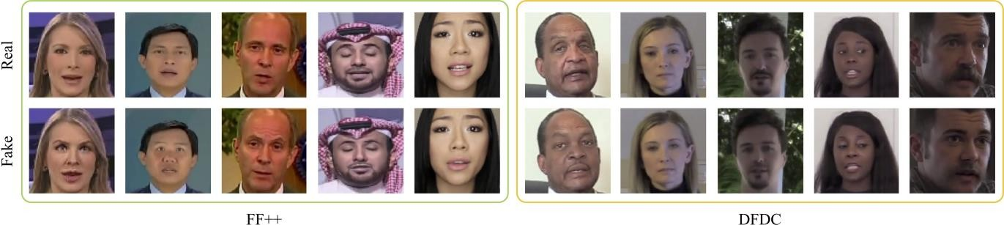

Fig. 1. Sample faces extracted from FF++ and DFDC datasets. For each pristine face, we show a corresponding fake sample generated from it.

steps, further hindering classic forensic detectors performance. In this paper, we tackle the problem of detecting facial manipulation operated through modern solutions. In particular, we focus on all the manipulation techniques reported in [17] (i.e., deepfakes, Face2Face, Face Swap and Neural Textures) and in the Facebook DFDC started on Kaggle in December 2019 [18]. Within this context, we study the possibility of using an ensemble of different CNN trained models. We consider EfficientNetB4 [19] and propose a modified version of it obtained by adding an attention mechanism [20]. More- over, for each network, we investigate two different training
strategies, one of which is based on the Siamese paradigm.
As one of the big challenges is to be able to run a forensic detector in real-world scenarios, we develop our solution keeping computational complexity at bay. Specifically, we consider the strong hardware and time constraints imposed by the DFDC [18]. This means that the proposed solution must be able to analyze 4 000 videos in less than 9 hours using at most a single NVIDIA P100 GPU. Moreover, the trained models must occupy less than 1GB of disk space.
Evaluation is performed on two disjoint datasets: FF++ [17], which has been recently proposed as a public benchmark; DFDC [18], which has been released as part of the DFDC Kaggle competition. Fig. 1 depicts a few examples of faces extracted from the two datasets, reporting pristine and ma- populated samples. Results show that the proposed attention- based modification as well as the Siamese training strategy help the ensemble system in outperforming the baseline reported in FF++ on both datasets. Moreover, the proposed attention- based solution provides interesting insights on which part of each frame drives face manipulation detection, thus enabling a small step forward towards the explainability of the network results.
The rest of the paper is structured as follows. Section II reports a literature review of the latest related work. Section III reports all the details about the proposed method. Section IV details the experimental setup. Section V collects all the achieved results. Finally, Section VI concludes the paper.

Related work
Multiple video forensics techniques have been proposed for a variety of tasks in the last few years [7]–[9]. However,
since the forensics community has become aware of the po- tertial social risks introduced by the latest facial manipulation techniques, many detection algorithms have been proposed to detect this kind of forgeries [16].
Some of the proposed techniques focus on a CNN-based frame-by-frame analysis. For instance, Mesonota is proposed in [21]. This is a relatively shallow CNN with the goal of detecting fake faces. The authors of [17] have shown that this network is outperformed by Captioned retrained on purpose. Alternative techniques exploit also the temporal evolution of video frames through Long Short-Term Memory (LSTM) analysis. This is the case of [22] and [23], which first extract a series of frame-based features, and then put them together
with a recurrent mechanism.
Other methods leverage specific processing traces. This is the case of [24], where the authors exploit the fact that deepfake donor faces are warped in order to realistically stick to the host video. They therefore propose a detector that captures warping traces.
In order to overcome the limitation of pixel analysis, other techniques are based on a semantic analysis of the frames. In [25], a technique that learns to distinguish natural and fake head pose is proposed. Conversely, the authors of [26] focus on inconsistent lighting effects. Alternatively, [27] reports a methodology based on eye blinking analysis. Indeed, the first generation of deepfake videos was showing some eye artifacts that could be captured with this method. Unfortunately, the more the manipulation techniques produce realistic results, the less semantic methods work.
Finally, other techniques provide additional localization information. The authors of [28] propose a multi-task learning method that provides a detection score together with a segment- station mask. Alternatively, in [29], an attention mechanism is proposed.
Inspired by the state of the art, in this paper we focus on network ensembles, proposing a solution that works on multiple datasets and is sufficiently lightweight according to DFDC competition rules [18].

Proposed method
In this section, we describe our proposed method for video face manipulation detection, i.e., given a video frame, to detect whether faces are real (pristine) or fake.


The proposed method is based on the concept of enemy- bling. Indeed, it is well-known that model assembling may lead to better prediction performance. We therefore focus on investigating whether and how it is possible to train different
2x
4x
4x
6x
6x
8x
2x
f (I)
Attention
224 x 224 x 3
Conv 3 x 3
112 x 112 x 48
CNN-based classifiers to capture different high-level semantic I information that complement one another, thus contributing to the ensemble for this specific problem.
To do so, we consider as starting point the Efficient Net family of models, proposed in [19] as a novel approach for the automatic scaling of CNNs. This set of architectures
EfficientNetB4

achieves better accuracy and efficiency with respect to other state-of-the-art CNNs, and actually revealed to be very useful to fulfil hardware and time constraints imposed by DFDC. Given an Efficient Net architecture, we propose to follow two paths to make the model beneficial for the enabling. On one hand, we propose to include an attention mechanism, which also provides the analyst with a method to infer which portion of the investigated video is more informative for the classification process. On the other hand, we investigate how Siamese training strategies can be included into the learning process for extrapolating additional information about the data. In the following, more details are provided about Efficient- Net architecture with the proposed attention mechanism and the network training strategies.
MBConv1 3 x 3
112 x 112 x 24
MBConv6 3 x 3
28 x 28 x 56
56 x 56 x 32
Conv 1x1
MBConv6 5 x 5
28 x 28 x 1
28 x 28 x 56
Sigmoid
MBConv6 3 x 3
28 x 28 x 1
14 x 14 x 112
28 x 28 x 56
MBConv6 5 x 5
14 x 14 x 160
MBConv6 5 x 5
7 x 7 x 272
MBConv6 3 x 3
7 x 7 x 448
Conv 1 x 1 & Pooling & FC
1792

Efficient Net and attention mechanism
Among the family of Efficient Net models, we choose the EfficientNetB4 as the baseline for our work, motivated by the good trade-off offered by this architecture in terms of dimensions (i.e., number of parameters), run time (i.e., FLOPS cost) and classification performance. As reported in [19], with 19 million of parameters and 4.2 billion of FLOPS, Effi- cientNetB4 reaches the 83.8% top-1 accuracy on the ImageNet
[30] dataset. On the same dataset, Captioned, used as face manipulation detection baseline method by the authors of [17], reaches the 79% top-1 accuracy at the expense of 23 million parameters and 8.4 billion FLOPS.
EfficientNetB4 architecture is represented within the blue block in Fig. 2, where all layers are defined using the same nomenclature introduced in [19].
The input to the network is a squared color image I, i.e., in our experiments, the face extracted from a video frame. As a matter of fact, authors of [17] recommend to track face information instead of using the full frame as input to the network for increasing the classification accuracy. Moreover, faces can be easily extracted from frames using any of the widely available face detectors proposed in the literature [31], [32]. The network output is a feature vector of 1792 elements, defined as f (I). The final score related to the face is the result of a classification layer.
The proposed variant of the standard EfficientNetB4 Archi- texture is inspired by the several contributions in the natural language processing and computer vision fields that make use of attention mechanisms. Works such as the transformer
[20] and residual attention networks [33] show how it is possible for a neural network to learn which part of its input
Fig. 2. Blue block: EfficientNetB4 model. If the red block is embedded into the network, an attention mechanism is included in the model, defining the proposed EfficientNetB4Att architecture.

(being an image or a sequence of words) is more relevant for accomplishing the task at hand. In the context of video deepfake detection, it would be of great benefit to discover which portion of the input gave the network more information for its decision-making process. We thus explicitly implement an attention mechanism similar to the one already exploited by the Efficient Net itself, as well as to the self-attention mechanisms presented in [29], [34]:
  - we select the feature maps extracted by the Efficient- NetB4 up to a certain layer, chosen such that these features provide sufficient information on the input frame without being too detailed or, on the contrary, too unrefined. To this purpose, we select the output features
at the third Macon block which have size 28×28×56;
  - we process the feature maps with a single convolutional
layer with kernel size 1 followed by a Sigmoid activation function to obtain a single attention map;
  - we multiply the attention map for each of the feature maps at the selected layer.
For clarity’s sake, the attention-based module is depicted in the red block of Fig. 2.
On one hand, this simple mechanism enables the network to focus only on the most relevant portions of the feature maps, on the other hand it provides us with a deeper insight on which parts of the input the network assumes as the most informative. Indeed, the obtained attention map can be easily mapped to the input sample, highlighting which elements of it have been given more importance by the network. The result of the attention block is finally processed by the remaining layers of EfficientNetB4. The whole training procedure can be executed end-to-end, and we call the resulting network EfficientNetB4Att.

Network training
We train each model according to two different training paradigms: (i) end-to-end, and; (ii) Siamese. The former riper- sent a more classical training strategy, also used as evaluation metrics in the contest of DFDC. The latter aims at exploiting the generalization capabilities offered by the networks in order to obtain a feature descriptor that privileges the similarity between samples belonging to the same class. The ultimate goal is to learn a representation in the encoding space of the

network’s layers that well separates samples (i.e., faces) of the real and fake class.
  - End-to-end training: We feed the network with a sample face, and the network returns a face-related score yˆ. Notice that this score is not passed through a Sigmoid activation function yet. The weights update is led by the commonly used Log Loss function
quality videos are generated using a constant rate quantization parameter equal to 23 and 40, respectively.
DFDC is the training dataset released for the homologous Kaggle challenge. It is composed by more than 119 000 video sequences, created specifically for this challenge, representing both real and fake videos. The real videos are sequences of ac- tors taking into account diversity in several axes (gender, skin-

L = − 1 N
[y log (S(yˆ )) + (1 − y ) log (1 − S(yˆ ))] ,
tone, age, etc.) recorded with arbitrary backgrounds to bring visual variability. The fake videos are created starting from the

L i i i
N
i=1
i
(1)
real ones and applying different Deepfake techniques, e.g., different face swap algorithms. Notice that we do not know

where yˆi represents the itch face score, yi ∈ {0, 1} the related face label. Specifically, label 0 is associated with faces coming from real pristine videos and label 1 with fake videos. N is
the total number of faces used for training and S (·) is the Sigmoid function.

  - Siamese training: Inspired by computer vision works that generate local feature descriptors using CNNs, we adopt the triplet margin loss, first proposed in [35]. Recalling that f (I) is the non-linear encoding obtained by the network for
an input face I (see Fig. 2), being · 2 the L2 norm, the triplet margin loss is defined as
LT = max (0, µ + δ+ − δ−), (2)
with δ+ = f (Ia) − f (Ip) ₂, δ− = f (Ia) − f (In) ₂ and µ is a strictly positive margin. In this case Ia, Ip and In are, respectively:
    - Ia the anchor sample (i.e., a real face);
    - Ip a positive sample, belonging to the same class as Ia
(i.e., another real face);
    - In a negative sample, belonging to a different class than
Ia (i.e., a fake face).
We then finalize the training by finetuning a simple classic- fiction layer on top of the network, following the end-to-end approach described before.

Experiments
In this section we report all the details regarding the used datasets and experimental setup.

Dataset
We test the proposed method on two different datasets: FF++ [17]; DFDC [18].
FF++ is a large-scale facial manipulation dataset generated using automated state-of-the-art video editing methods. In detail, two classical computer graphics approaches are used, i.e., Face2Face [2] and Face Swap [5], together with two learning-based strategies, i.e., Deepfakes [4] and Neural Tex- trues [3]. Every method is applied to 1000 high quality pris- tine videos downloaded from YouTube, manually selected to present nearly front-facing subjects without occlusions. All the sequences contain at least 280 frames. Eventually, a database of more than 1.8 million images from 4000 manipulated videos is built. In order to simulate a realistic setting, videos are compressed using the H.264 codec. High quality as well as low
the precise algorithms used to generate fake videos, since for the time being the complete dataset (i.e., with the public and private testing sequences and possibly an explanation of the creation procedure) has not been released yet. The sequence length is roughly 300 frames, and the classes are strongly unbalanced towards the fake one, counting roughly 100 000 fakes and 19 000 reals.

Networks
In our experiments, we consider the following networks:
  - Captioned, since it is the best performing model used in [17], thus being the natural yardstick for our experimental campaign;
  - EfficentNetB4, as it achieves better accuracy and Effi- Cincy than other existing methods [19];
  - EfficentNetB4Att, which should discriminate relevant parts of the face sample from irrelevant ones.
Each model is trained and tested separately over both the considered datasets. Specifically, regarding FF++, we consider only videos generated with constant rate quantization equal to
23. Captioned is trained using the same approach of [17], whereas the two Efficient Net models are trained following the end-to-end as well as the Siamese fashion described in Sec- ton III-B. In doing so, we end up with 4 trained models: Effi- cientNetB4 and EfficientNetB4Att which are trained with the classical end-to-end approach, together with EfficientNetB4ST and EfficientNetB4AttST, trained using the Siamese strategy. All these EfficientNetB4-derived models can contribute to the final assembling.

Setup
We adopt a different split policy for each dataset. We split DFDC according to its folder structure, using the first 35 folders for training, folders from 36 to 40 for validation and the last 10 folders for testing. Regarding FF++, we use a similar split as in [17] selecting 720 videos for training, 140 for validation and 140 for test from the pool of original sequences taken from YouTube. The corresponding fake videos are assigned to the same split. All the results are shown on the test sets.
In our experiments, we only consider a limited number of frames for each video. In training phase, this choice is motivated by two main considerations: (i) when using a really small number of frames per video, there is a strong tendency to overfit; (ii) increasing the number of frames does not improve

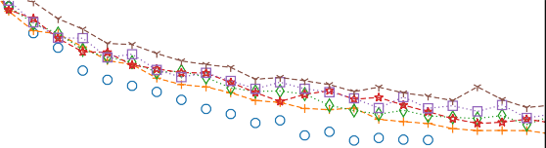

0.4

0.3
Training loss

0.2

0.1
1000 2000 3000 4000 5000 6000 7000 8000 9000 10000
Iteration

0.5
Validation loss

0.4

0.3

1000 2000 3000 4000 5000 6000 7000 8000 9000 10000
Iteration

Fig. 3. Training and validation loss curves for Captioned on FF++, while varying the number of frames per video (FPV).

performances in a justifiable manner. This phenomenon can be noticed in Fig. 3, which reports training and validation losses as a function of training iterations, selecting a variable number of frames per video. It is worth noting that the minimum validation loss does not improve selecting 15 frames per video instead of 32, however choosing 32 frames per video helps to prevent overfitting. For testing, we should also take into account the hardware and time constraints imposed by the DFDC challenge. With this in mind, we limit the number of analyzed frames from each sequence to 32 for both training and testing phases. Even in this setting, the dimensions of the datasets remain remarkable: for the FF++, we end up with roughly 1.6 million images, while for the DFDC with 3.4 million frames.
In this perspective, we can further reduce the amount of data processed by the networks by recalling that not all the frame information is useful for the deepfake detection process [17]. Indeed, we can mainly focus our analysis on the region where the face of the subject is located. Consequently, as a pre-processing step, we extract from each frame the faces of the scene subjects using the Blaze Face extractor [32], that, in our experiments, proved to be faster than the MTCNN detector
[31] used by the authors of [17]. In case more than one face is detected, we keep the face with the best confidence score. The resulting input for the networks is the squared color image I
introduced in section III, of size 224 × 224 pixel.
During training and validation, to make our models more
robust, we perform data augmentation operations on the input faces. In particular, we randomly apply downscaling, horizon- Tal flipping, random brightness contrast, hue saturation, noise addition and finally JPEG compression. Specifically, we resort to Album [36] as our data-augmentation library, while we use torch [37] as Deep Learning framework. We train the models using Adam [38] optimizer with hyperparameters equal to β1 = 0.9, β2 = 0.999, ϵ = 10⁻⁸, and initial learning rate equal to 10⁻⁵.
Independently from the used training strategy, given the size
of the datasets, we never train our networks for a complete epoch. Specifically:
  - for the end-to-end training, we either train for a maximum of 20k iterations, indicating as iteration the processing of a batch of 32 faces (16 real, 16 fake) taken randomly and evenly across all the videos of the train split, or until reaching a plateau on the validation loss. Validation of the model in this context is performed every 500 training iterations, on 6000 samples taken again evenly and randomly across all videos of the validation set. The initial learning rate is reduced of a 0.1 factor if the validation loss does not decrease after 10 validation routines (5000 training iterations), and the training is stopped when we reach a minimum learning rate of
1 × 10⁻¹⁰;
  - for the Siamese training, the feature extractor is trained
using the same number of iterations, validation routine and learning rate scheduling of the end-to-end training. The main difference lies in the different loss function used (as explained in Section III), and in the composition of the batch, which in this case is made by 12 triplets of samples (6 real-fake-fake, 6 fake-fake-real) selected across all videos of the set considered. Regarding the parameter µ in (2), we set it to 1 after some preliminary experiments. The fine-tuning of the classification layer is then executed in a successive step following the end-to- end training paradigm with the hyperparameters specified above.
We finally run our experiments on a machine equipped with an Intel Xeon E5-2687W-v4 and a NVIDIA Titan V.

Results
In this section we collect all the results obtained during our experimental campaign.

- EfficientNetB4Att explainability
In order to show the effectiveness of the attention mecha- ins in extracting the most informative content of faces, we evaluate the attention map computed on a few faces of FF++. Referring to Fig. 2, we select the output of the Sigmoid layer in the attention block, which is a 2D map with size 28 × 28.
Then, we up-scale it to the input face size (224 × 224), and superimpose this to the input face. Results are reported in
Fig. 4. It is worth noting that this simple attention mechanism enables to highlight the most detailed portion of faces, e.g., eyes, mouth, nose and ears. On the contrary, flat regions (where gradients are small) are not informative for the network. As a matter of fact, it has been shown several times that artifacts of deepfake generation methods are mostly localized around facial features [16]. For instance, roughly modeled eyes and teeth, showing excessively white regions, are still the main trademarks of these methods.

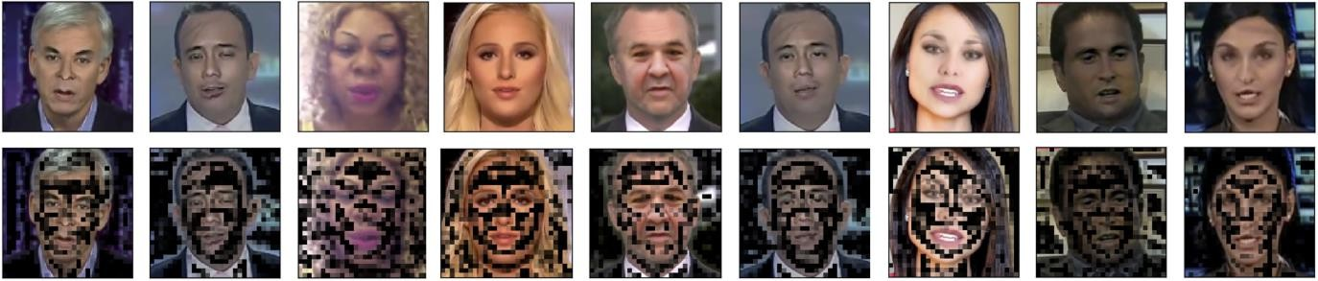

Fig. 4. Effect of the attention on faces under analysis. Given some faces to analyze (top row), the attention network tends to select regions like eyes, mouth and nose (bottom row). Faces have been extracted from FF++ dataset.

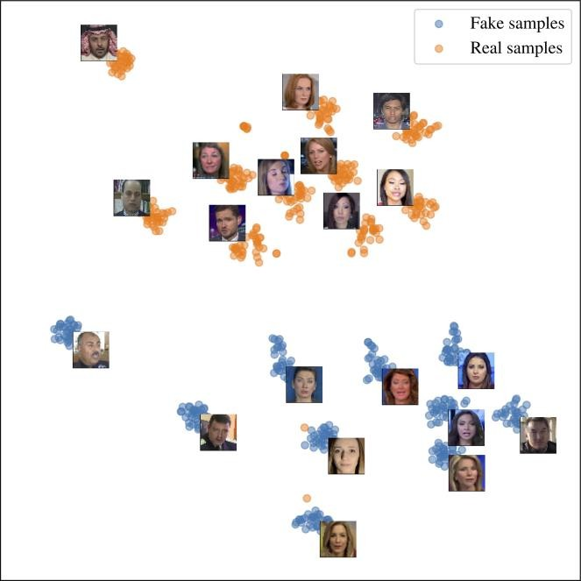
- Siamese features
In order to understand whether the features produced by the encoding of the network when trained in Siamese fashion are discriminatory for the task, we computed a projection over a reduced space using the well-known algorithm t- SNE [39]. In Fig. 5 we show the projection obtained by means of EfficientNetB4Att starting from 20 FF++ videos. We can clearly see how frames of the same videos’ clusters into small sub-regions. More importantly, all the real samples cluster into the top region of the chart, whereas the fake samples are in the bottom region. Frames of the same video’s clusters into smaller sub-regions. This justifies the choice to adopt this particular training paradigm in addition to the classical end- to-end approach.

Architecture independence
As we want to understand whether the different networks can be used in an ensemble, we explore whether the scores extracted by each model are independent to some extent.
In Fig. 6, all plots outside of the main diagonal show that different networks provide slightly different scores for each frame. Indeed, the point clouds do not perfectly align on a shape that can be easily described by a simple relation. This motivates us in using the different trained models in an ensemble way. If all networks were perfectly correlated, this would not be reasonable.

Face manipulation detection capability
In this section, we report the average results achieved by the baseline network (i.e., Captioned) and the 4 proposed mod- ells (i.e., EfficientNetB4, EfficientNetB4Att, EfficientNetB4ST and EfficientNetB4AttST). We also verify our guess behind the use of an ensemble, specifically combining two, three or even all the proposed models. In this case, the final score associated with a face is simply computed as the average between the scores returned by the single models.
In Table I we report the AUC (computed binarizing the network output with different thresholds) and Log Loss ob.- tainted in our experiments. Results are provided in a per-frame fashion.

Fig. 5. t-SNE visualization of features obtained by EfficientNetB4Att with Siamese training. Faces have been extracted from FF++ dataset.

Analyzing these results, it is worth noting that the strategy of model assembling generally awards in terms of perform- minces. As somehow expected, best top-3 results are always reached by a combination of 2 or more networks, meaning that network fusion helps both the accuracy of the deepfake detection (estimated by means of AUC) and the quality of the detection (estimated by means of Log Loss measure). Indeed, on both datasets, Log Loss and AUC are always better than the baseline.

Kaggle results
In order to gain a deeper insight on the proposed solution performance, we also participated to the DFDC challenge on Kaggle [18] as ISPL team. The ultimate goal of the competition was to build a system able to tell whether a video is real or fake. The DFDC dataset used in this paper represents the training dataset released by the competition host, while the

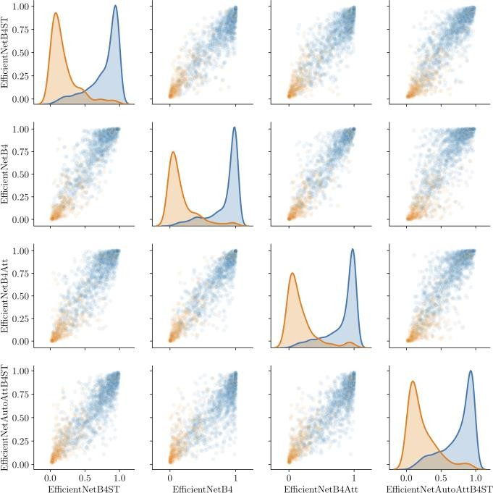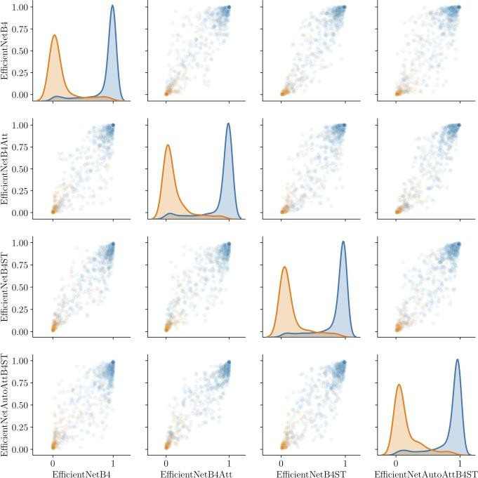
(a) FF++ (b) DFDC
Fig. 6. Pair-plot showing the score distribution for real (orange •) and fake (blue •) samples for each pair of networks on FF++ (a) and DFDC (b) datasets.

TABLE I
area under the curve (AUC) and Log Loss obtained with different network combinations over all the datasets. Top-3 results per column in bold, baseline in italics.

Exception  Net B4 | Effi B4ST | content B4Att | B4AttST | AU FF++ | C  DFDC | Log Lo FF++ | ss DFDC
C |  |  |  | 0.9273 | 0.8784 | 0.3844 | 0.4897
C |  |  |  | 0.9382 | 0.8766 | 0.3777 | 0.4819
 | C |  |  | 0.9337 | 0.8658 | 0.3439 | 0.5075
 |  | C |  | 0.9360 | 0.8642 | 0.3873 | 0.5133
 |  |  | C | 0.9293 | 0.8360 | 0.3597 | 0.5507
C | C |  |  | 0.9413 | 0.8800 | 0.3411 | 0.4687
C |  | C |  | 0.9428 | 0.8785 | 0.3566 | 0.4731
C |  |  | C | 0.9421 | 0.8729 | 0.3370 | 0.4739
 | C | C |  | 0.9423 | 0.8760 | 0.3371 | 0.4770
 | C |  | C | 0.9393 | 0.8642 | 0.3289 | 0.4977
 |  | C | C | 0.9390 | 0.8625 | 0.3515 | 0.4997
C | C | C |  | 0.9441 | 0.8813 | 0.3371 | 0.4640
C | C |  | C | 0.9432 | 0.8769 | 0.3269 | 0.4684
C |  | C | C | 0.9433 | 0.8751 | 0.3399 | 0.4717
 | C | C | C | 0.9426 | 0.8719 | 0.3304 | 0.4800
C | C | C | C | 0.9444 | 0.8782 | 0.3294 | 0.4658

evaluation is performed over two different testing datasets: (i) the public test dataset; (ii) the private test dataset. Participants were not aware of the composition of those datasets (e.g., the provenance of the sequences, the techniques used for generating fakes, etc.), apart from the number of videos in public test set, which is roughly 4000. The final solution proposed by our team was an ensemble of the 4 proposed models, which led us to top 3% on the leaderboard computed against the public test set. For the time being, the leaderboard computed over the private test set has not been disclosed yet.
- Conclusions
Being able to detect whether a video contains manipulated content is nowadays of paramount importance, given the significant impact of videos in everyday life and in mass communications. In this vein, we tackle the detection of facial manipulation in video sequences, targeting classical computer graphics as well as deep learning generated fake videos.
The proposed method takes inspiration from the family of Efficient Net models and improves upon a recently proposed solution, investigating an ensemble of models trained using two main concepts: (i) an attention mechanism which genre- ate a human comprehensible inference of the model, increase- Ing the learning capability of the network at the same time; (ii) a triplet Siamese training strategy which extracts deep features from data to achieve better classification performances.
Results evaluated over two publicly available datasets con- training almost 120 000 videos reveal the proposed ensemble strategy as a valid solution for the goal of facial manipulation detection.
Future work will be devoted to the embedding of temporal information. As a matter of fact, intelligent voting schemes when more frames are analyzed at once might lead to an increased accuracy.

References

- M. Zoller, J. Thies, P. Garrido, D. Bradley, T. Beeler, P. Prez,
M. Stamm Inger, M. Niner, and C. Theobald, “State of the art on monocular 3d face reconstruction, tracking, and applications,” Computer Graphics Forum, vol. 37, pp. 523–550, 2018.

- J. Thies, M. Zoll Hofer, M. Stamm Inger, C. Theobald, and M. Neuner, “Face2face: Real-time face capture and reenactment of grub videos,” in Proceedings of the IEEE conference on computer vision and pattern recognition, 2016, pp. 2387–2395.
- J. Thies, M. Solnhofen, and M. Neuner, “Deferred neural rendering: Image synthesis using neural textures,” ACM Transactions on Graphics (TOG), vol. 38, no. 4, pp. 1–12, 2019.
- “Deepfakes GitHub,” https://github.com/deepfakes/faceswap.
- “Face swap,” https://github.com/MarekKowalski/FaceSwap/.
- S. Agarwal, H. Farid, Y. Gu, M. He, K. Nagano, and H. Li, “Protecting world leaders against deep fakes,” in IEEE Conference on Computer Vision and Pattern Recognition Workshops (CVPRW), 2019.
- A. Rocha, W. Scheirer, T. Boult, and S. Goldenstein, “Vision of the unseen: Current trends and challenges in digital image and video forensics,” ACM Computing Surveys, vol. 43, no. 26, pp. 1–42, 2011.
- S. Milani, M. Fontana, P. Betaine, M. Barni, A. Piva, M. Pagliacci, and S. Tufaro, “An overview on video forensics,” APSIPA Transactions on Signal and Information Processing, vol. 1, p. e2, 2012.
- M. C. Stamm, Min Wu, and K. J. R. Liu, “Information forensics: An overview of the first decade,” IEEE Access, vol. 1, pp. 167–200, 2013.
- P. Betaine, S. Milani, M. Tallahatchie, and S. Tufaro, “Codec and gop identification in double compressed videos,” IEEE Transactions on Image Processing (TIP), vol. 25, pp. 2298–2310, 2016.
- D. Quezada, M. Fontane, D. Shalane, F. Prez-Gonzlez, A. Piva, and M. Barni, “Video integrity verification and gap size estimation via generalized variation of prediction footprint,” IEEE Transactions on Information Forensics and Security (TIFS), vol. 15, pp. 1815–1830, 2020.
- P. Betaine, S. Milani, M. tagasaste, and S. tuber, “Local tamper- in detection in video sequences,” in IEEE International Workshop on Multimedia Signal Processing (MMSP), 2013.
- L. Damianos, D. Cozzolino, G. Poggi, and L. Verdolaga, “A patch match- based dense-field algorithm for video copy move detection and localized- tin,” IEEE Transactions on Circuits and Systems for Video Technology (TCSVT), vol. 29, pp. 669–682, 2019.
- M. C. Stamm, W. S. Lin, and K. J. R. Liu, “Temporal forensics and anti-forensics for motion compensated video,” IEEE Transactions on Information Forensics and Security (TIFS), vol. 7, pp. 1315–1329, 2012.
- A. Gerona, M. Fontanne, T. Bianchi, A. Piva, and M. Barni, “A video forensic technique for detecting frame deletion and insertion,” in 2014 IEEE International Conference on Acoustics, Speech and Signal Pro- casing (ICASSP), 2014, pp. 6226–6230.
- L. Verdolaga, “Media forensics and deepfakes: an overview,” 2020.
- A. Roesler, D. Cozzolino, L. verdolaga, C. Riess, J. Thies, and
M. Neuner, “Face Forensics++: Learning to detect manipulated facial images,” in International Conference on Computer Vision (ICCV), 2019.
- “Deepfake Detection Challenge (DFDC),” https://deepfakedetectionchallenge.ai/, 2019.
- M. Tan and Q. V. Le, “Efficient net: Rethinking model scaling for convolutional neural networks,” in International Conference on Machine Learning, (ICML) 2019, ser. Proceedings of Machine Learning Research, vol. 97. PMLR, 2019, pp. 6105–6114.
- A. Vaswani, N. Shabeer, N. Parmar, J. Ozokerite, L. Jones, A. N. Gomez, L. Kaiser, and I. Polishing, “Attention is all you need,” in Advances in Neural Information Processing Systems (NIPS), I. Guyon,
U. V. Lux burg, S. Bengio, H. Wallach, R. Fergus, S. Vishwanathan, and
R. Garnett, Eds. Curran Associates, Inc., 2017, pp. 5998–6008.
- D. Achaar, V. Nozick, J. Yamagishi, and I. Echizen, “mesonota: a compact facial video forgery detection network,” in IEEE International Workshop on Information Forensics and Security (WIFS), 2018.
- P. Korshunov and S. Marcel, “Deepfakes: a new threat to face recognin- tin? assessment and detection,” Corr, vol. abs/1812.08685, 2018.
- D. Guvera and E. J. Delp, “Deepfake Video Detection Using Recurrent Neural Networks,” IEEE International Conference on Advanced Video and Signal-Based Surveillance (AVSS), 2019.
- Y. Li and S. Lyu, “Exposing deepfake videos by detecting face warping artifacts,” in IEEE Conference on Computer Vision and Pattern Reclog- nations Workshops (CVPRW), 2019.
- X. Yang, Y. Li, and S. Lyu, “Exposing deep fakes using inconsistent head poses,” in IEEE International Conference on Acoustics, Speech and Signal Processing (ICASSP), 2019.
- F. Matern, C. Riess, and M. Steiniger, “Exploiting visual artifacts to expose deepfakes and face manipulations,” in IEEE Winter Applications of Computer Vision Workshops (WACVW), 2019.
- Y. Li, M. Chang, and S. Lyu, “In cite oculi: Exposing AI created fake
videos by detecting eye blinking,” in IEEE International Workshop on Information Forensics and Security (WIFS), 2018.
- H. H. Nguyen, F. Fang, J. Yamagishi, and I. Echizen, “Multi-task learning for detecting and segmenting manipulated facial images and videos,” Corri, vol. abs/1906.06876, 2019.
- H. Dang, F. Liu, J. Stehouwer, X. Liu, and A. Jain, “On the detection of digital face manipulation,” 2019.
- J. Deng, W. Dong, R. Socher, L.-J. Li, K. Li, and L. Fei-Fei, “ImageNet: A Large-Scale Hierarchical Image Database,” in CVPR09, 2009.
- K. Zhang, Z. Zhang, Z. Li, and Y. Qiao, “Joint face detection and alignment using multitask cascaded convolutional networks,” IEEE Signal Processing Letters, vol. 23, no. 10, pp. 1499–1503, 2016.
- V. Bassarisks, Y. Kartune, A. Vanunu, K. Raveendran, and
M. Grundmann, “Blueface: Sub-millisecond neural face detection on mobile opus,” Corr, vol. abs/1907.05047, 2019. [Online]. Available: http://arxiv.org/abs/1907.05047
- F. Wang, M. Jiang, C. Qian, S. Yang, C. Li, H. Zhang, X. Wang, and
X. Tang, “Residual attention network for image classification,” in The IEEE Conference on Computer Vision and Pattern Recognition (CVPR), July 2017.
- J. Hu, L. Shen, and G. Sun, “Squeeze-and-excitation networks,” in Proc. IEEE/CVF Conf. Computer Vision and Pattern Recognition, 2018, pp. 7132–7141.
- J. Wang, Y. Song, T. Leung, C. Rosenberg, J. Wang, J. Philbin, B. Chen, and Y. Wu, “Learning fine-grained image similarity with deep ranking,” in Proceedings of the IEEE Conference on Computer Vision and Pattern Recognition, 2014, pp. 1386–1393.
- E. K. V. I. I. A. Busload, A. Barinov and A. A. Kalinin, “Augmentations: fast and flexible image augmentations,” Arrive e-prints, 2018.
- A. Paczki, S. Gross, F. Massa, A. Lerer, J. Bradbury,
G. Chanan, T. Killeen, Z. Lin, N. Gimel Shein, L. Antigo,
A. Desma Ison, A. Kopf, E. Yang, Z. DeVito, M. Raison, A. Tejani,
S. Chellamuthu, B. Steiner, L. Fang, J. Bai, and S. Chintala, “Porch: An imperative style, high-performance deep learning library,” in Advances in Neural Information Processing Systems 32, H. Wallach, H. Larochelle, A. Bergelmir, F. d’Alene´-Buc,
E. Fox, and R. Garnett, Eds. Curran Associates, Inc., 2019,
pp. 8024–8035. [Online]. Available: http://papers.neurips.cc/paper/ 9015-pytorch-an-imperative-style-high-performance-deep-learning-library. pdf
- D. Kingma and J. Ba, “Adam: a method for stochastic optimization. arrive: 14126980,” 2014.
- L. van der Maten and G. Hinton, “Visualizing data using t-SNE,” Journal of Machine Learning Research, vol. 9, pp. 2579–2605, 2008. [Online]. Available: http://www.jmlr.org/papers/v9/vandermaaten08a. html

